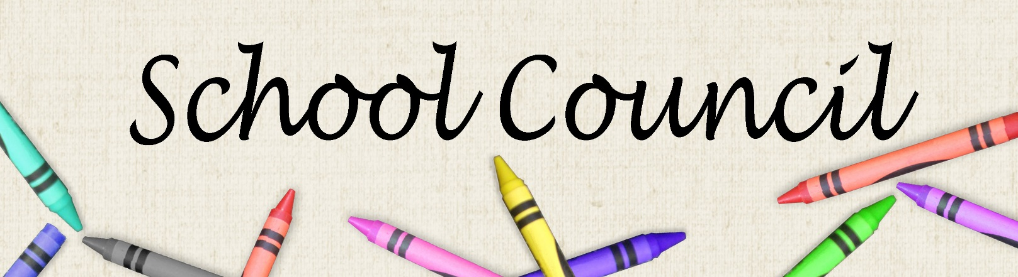
Introducing the 2018-2019 School Council
Co-Chairs: Sarah Kreick & Lisa Johnson
Treasurer: Pricia Evans
Secretary: Jessica Lovett
Bingo Co-ordinator: Sue Delouche

The Co-Chairs can be reached via email at rgsinclaircouncil@gmail.com
We are on Facebook, search for: R.G Sinclair Public School, Parent Council


Upcoming Meeting Dates
October 10th | November 14th
January 12th | February 13th
April 10th | May 8th
June 12th (tentative)

All meetings will be at 6:30pm and located at R.G. Sinclair. Childcare is always provided.


BINGO VOLUNTEERS NEEDED!!

R.G. Sinclair is fortunate to hold a permit with Treasure Chest Bingo Hall. By volunteering to work 2 or 4 hour blocks of time we are able to earn thousands of dollars for the enrichment of every student at our school.
There are several shifts that have yet to be covered, if we miss a shift or cancel any shifts, we risk losing our permit which would be a major loss. We need several more volunteers to round out our list and share the load. Training is provided. For more information or to add your name to our list please email Sue at bingorgsin@gmail.com

